**Things to read :**

<https://help.github.com/en/categories/getting-started-with-github>

<https://lab.github.com/paths>

<https://learngitbranching.js.org/>

<https://www.pluralsight.com/courses/code-school-git-real>

<https://guides.github.com/features/wikis/>

**Conditions**

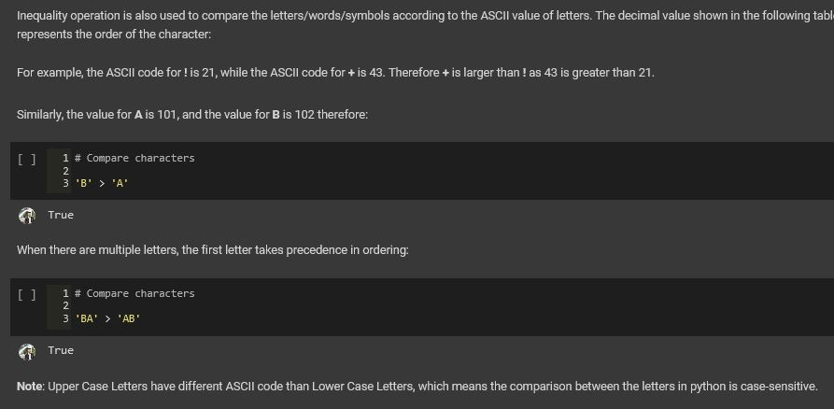

**Loops**

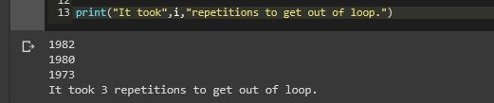

**Sesi 2**

**Function**

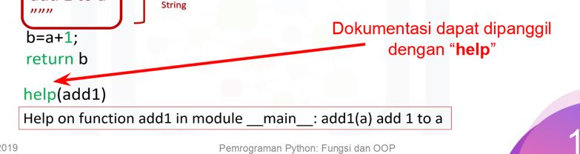

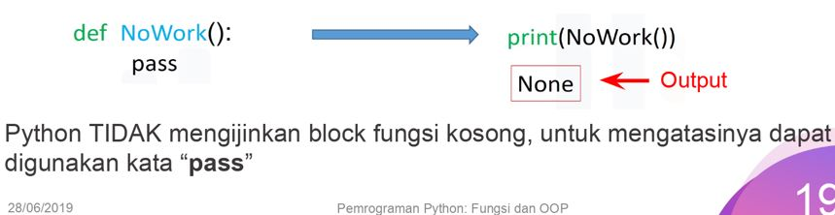

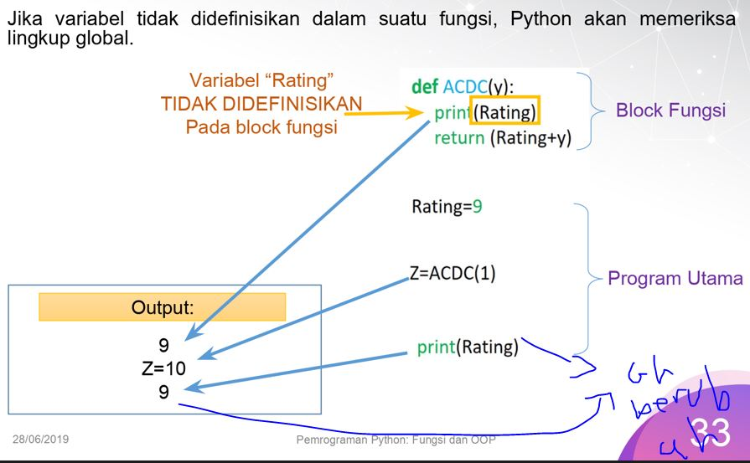

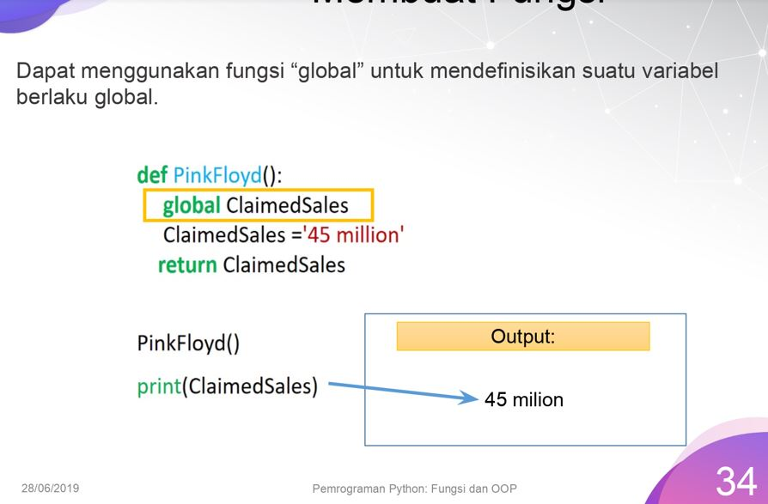

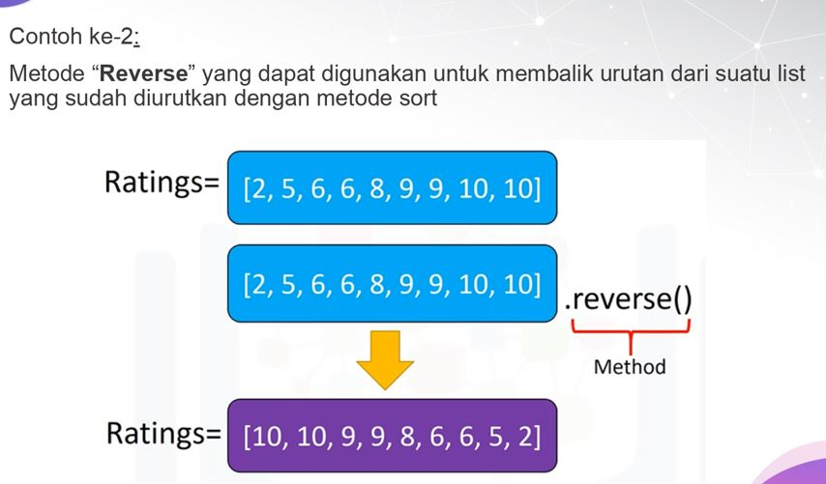

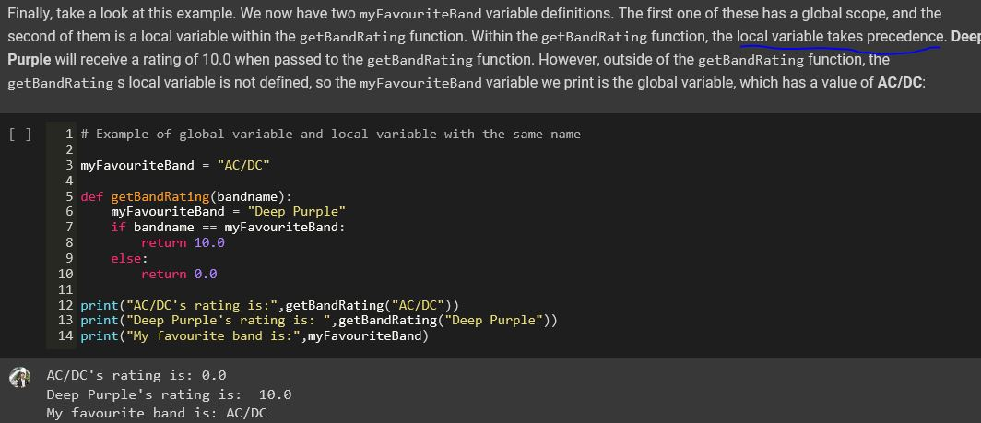

**Class**

